Journal of Rare Diseases: Case Report
Adult-onset pseudohypoparathyroidism presenting with tetany and trismus without Albright hereditary osteodystrophy in a Tanzanian woman: a case report
David George¹, Denis Rayner¹, Silas Frank Gamba¹, James Masanja^{1*}
¹ Department of Internal Medicine, Muhimbili National Hospital, Dar es Salaam, Tanzania
*Corresponding author: James Masanja, Department of Internal Medicine, Muhimbili National Hospital, P.O. Box 65000, Dar es Salaam, Tanzania. Email: jamesmasanja@gmail.com
ORCID identifiers: to be added by each author at submission.
Word count: abstract 245; main text (Background to Conclusion, excluding tables) 2274. Figures: 2. Tables: 4. References: 20. Supplementary material: Online Resource 1 (CARE checklist).

Abstract
Background Pseudohypoparathyroidism (PHP) is a rare group of disorders, with a prevalence of about 1 per 100,000, in which target tissues are resistant to parathyroid hormone (PTH). Most patients are diagnosed in childhood with the physical features of Albright hereditary osteodystrophy (AHO). Adult presentations without AHO are easily missed, particularly where molecular testing is unavailable.
Case presentation A 43-year-old Tanzanian woman presented with a five-month history of perioral and acral paraesthesia progressing to recurrent carpopedal spasms and, finally, trismus and generalised tetany that were initially attributed to tetanus. Chvostek's and Trousseau's signs were positive. She was obese but had no feature of AHO. Investigations showed hypocalcaemia (total calcium 1.90 mmol/L), hyperphosphataemia (1.60 mmol/L) and an elevated intact PTH (176.8 pg/mL) with normal magnesium, 25-hydroxyvitamin D and renal function, the biochemical signature of PTH resistance. Brain CT showed no intracranial calcification. Genetic testing was unavailable and a clinical diagnosis of PHP, most consistent with type 1B, was made. Symptoms resolved within 24 hours of intravenous calcium gluconate, and she remained well on calcitriol and oral calcium at three months.
Conclusions PHP can present for the first time in adult life without AHO or intracranial calcification. Hypocalcaemia with hyperphosphataemia and an elevated PTH in a patient with normal renal function, magnesium and vitamin D justifies a clinical diagnosis and immediate treatment where molecular testing is out of reach. Trismus and generalised spasms from hypocalcaemia can mimic tetanus, and serum calcium should be measured in every patient in whom tetanus is suspected.
Keywords Pseudohypoparathyroidism; Parathyroid hormone resistance; Hypocalcaemia; Tetany; Rare diseases; Tanzania

Background
Pseudohypoparathyroidism (PHP) comprises a heterogeneous group of rare disorders in which target tissues are resistant to parathyroid hormone (PTH), producing hypocalcaemia and hyperphosphataemia despite raised circulating PTH (Mantovani et al. 2018). Most forms result from genetic or epigenetic defects at the GNAS locus, which encodes the alpha subunit of the stimulatory G protein, or in downstream components of the PTH/PTH-related peptide signalling pathway; the umbrella term inactivating PTH/PTHrP signalling disorder (iPPSD) has been proposed to reflect this shared mechanism (Jüppner 2021; Thiele et al. 2016). PHP meets any definition of a rare disease: national registry data put its prevalence at 1.1 per 100,000 in Denmark and 1.2 per 100,000 in Japan (Takatani et al. 2023; Underbjerg et al. 2016), there are no population data from sub-Saharan Africa, and published African cases are few (Akpalu et al. 2023; Gicheru et al. 1983).
Most patients are diagnosed in childhood, and many have the physical features of Albright hereditary osteodystrophy (AHO): short stature, round face, obesity, brachydactyly and ectopic ossification. Patients with PHP type 1B, however, typically have PTH resistance with few or none of these features, so the diagnosis rests on the biochemical pattern (Jüppner 2021; Mantovani et al. 2018). In adults the diagnosis is easily missed, and in settings without access to molecular testing it must be made and acted on clinically (Mantovani et al. 2020). Late diagnosis in adulthood, sometimes after years of misattributed seizures or spasms, is well documented (Trejo et al. 2018).
We report a woman who presented in her fifth decade with severe hypocalcaemic tetany and trismus that initially raised the suspicion of tetanus, and whose biochemistry established PTH resistance in the absence of AHO or intracranial calcification. We are not aware of a previously published case from Tanzania. The report follows the CARE guidelines for case reports (Riley et al. 2017), and a completed CARE checklist is provided as Online Resource 1.

Case presentation

Patient information and clinical findings
A 43-year-old Tanzanian woman was referred to our tertiary hospital with progressive neuromuscular symptoms. She had no known chronic illness, no history of neck surgery or cervical irradiation, and had not taken any medication associated with hypocalcaemia. She did not use alcohol or tobacco, and there was no family history of a similar illness, of short stature or of skeletal abnormality.
About five months before admission she developed gradually progressive paraesthesia and numbness, first around the mouth and then in both hands and feet. Over the following months this progressed to painless twitching around the mouth and to recurrent, sustained, painful carpopedal spasms that increased in frequency and duration until she could no longer hold objects or walk comfortably. On the day before admission she developed trismus, was unable to speak, and had an episode of generalised tetany. Because tetanus remains endemic in Tanzania, tetanus was the first diagnosis considered by the referring clinicians, but there was no history of a wound or of any other feature of an infectious process. The clinical course is summarised in Table 1.
Table 1 Clinical timeline
Time | Clinical events and findings | Actions
About five months before admission | Onset of perioral paraesthesia and numbness, later spreading to both hands and feet | No medical consultation
Following months | Painless perioral twitching; recurrent, sustained, painful carpopedal spasms increasing in frequency and duration; difficulty holding objects and walking | No medical consultation
Day before admission | Trismus, inability to speak and an episode of generalised tetany; tetanus suspected by the referring clinicians | Referred to tertiary hospital
Day of admission | Positive Chvostek's and Trousseau's signs; hyperreflexia; obesity without features of Albright hereditary osteodystrophy. Total calcium 1.90 mmol/L, phosphate 1.60 mmol/L, intact PTH 176.8 pg/mL, normal magnesium, 25-hydroxyvitamin D and creatinine. ECG: sinus tachycardia, borderline QTc | Intravenous calcium gluconate in repeated 2 g boluses; symptoms resolved within 24 hours
During admission | Echocardiography normal; renal ultrasonography normal; non-contrast CT brain without intracranial calcification. Clinical diagnosis of PHP, most consistent with type 1B | Transition to oral calcitriol 0.25 µg daily and calcium carbonate 500 mg twice daily; counselling
Day 5 | Clinically well on oral therapy | Discharge; endocrine follow-up arranged; genetic testing recommended but unavailable locally; family assessment initiated
More than three months after discharge | Asymptomatic; no recurrence of neuromuscular symptoms; first-degree relatives without clinical or biochemical features of PHP | Continued monitoring of calcium, phosphate, PTH, thyroid and renal function
PHP, pseudohypoparathyroidism; PTH, parathyroid hormone; ECG, electrocardiogram; QTc, corrected QT interval
On examination she was alert and haemodynamically stable. She was obese, with a body mass index of 32.7 kg/m², but had no phenotypic feature of AHO: stature was normal, the face was not rounded, Archibald's metacarpal sign was negative, indicating no shortening of the fourth or fifth metacarpals, and there were no subcutaneous ossifications. Neurological examination showed symmetrical hyperreflexia (3+) in all four limbs. Chvostek's sign was positive, and inflation of a sphygmomanometer cuff above systolic pressure elicited carpal spasm (Trousseau's sign; Fig. 1).
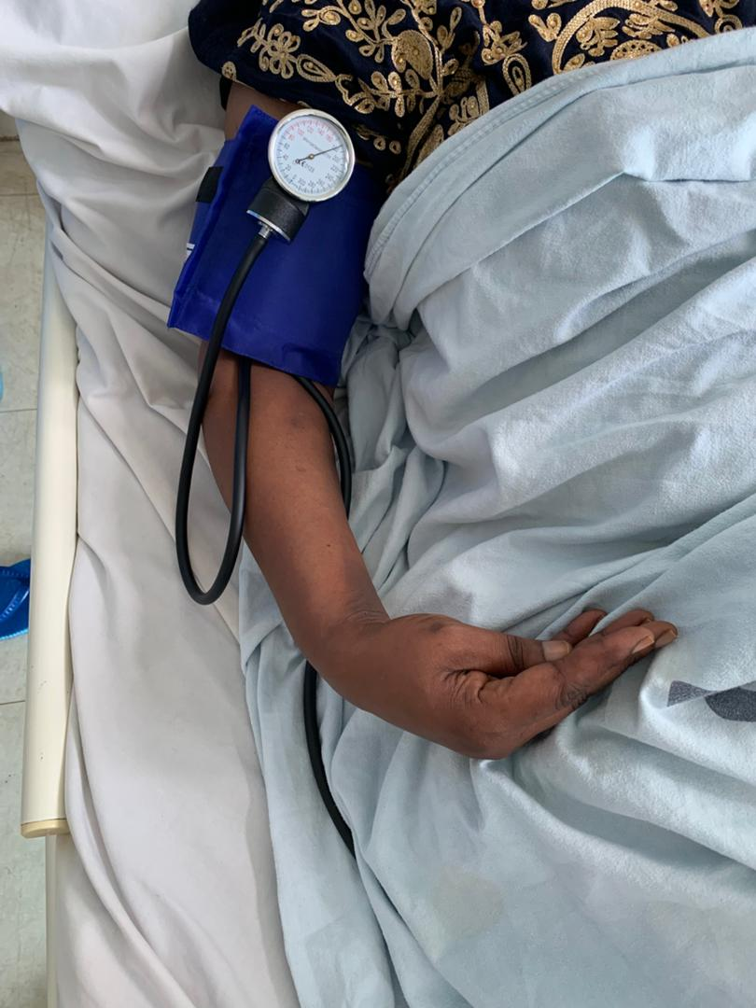
Fig. 1 Positive Trousseau's sign. Inflation of a sphygmomanometer cuff above systolic pressure elicited carpal spasm, with flexion of the wrist and metacarpophalangeal joints, extension of the interphalangeal joints and adduction of the thumb

Diagnostic assessment
The results of the initial investigations are shown in Table 2. Total serum calcium was 1.90 mmol/L (albumin-corrected 1.98 mmol/L; reference 2.10–2.55 mmol/L) and ionised calcium 0.43 mmol/L (reference 1.12–1.32 mmol/L). Serum phosphate was raised at 1.60 mmol/L (reference 0.81–1.45 mmol/L). Intact PTH was elevated at 176.8 pg/mL (18.7 pmol/L; reference 6–80 pg/mL) despite the hypocalcaemia. Serum magnesium (1.03 mmol/L), albumin (36.1 g/L), 25-hydroxyvitamin D (37.7 ng/mL, equivalent to 94 nmol/L) and creatinine (53.7 µmol/L) were normal, and arterial blood gas analysis (pH 7.41, PaCO₂ 36.7 mmHg, bicarbonate 25 mmol/L) excluded alkalosis as a precipitant of tetany. Thyroid function, reproductive hormones, liver function tests, HbA1c and glucose were within reference ranges.
Table 2 Laboratory and imaging findings on admission
Investigation | Result | Reference range
Total serum calcium | 1.90 mmol/L | 2.10–2.55 mmol/L
Albumin-corrected calciumª | 1.98 mmol/L | 2.10–2.55 mmol/L
Ionised calcium | 0.43 mmol/L | 1.12–1.32 mmol/L
Serum phosphate | 1.60 mmol/L | 0.81–1.45 mmol/L
Serum magnesium | 1.03 mmol/L | 0.66–1.07 mmol/L
Intact parathyroid hormone^{b} | 176.8 pg/mL (18.7 pmol/L) | 6–80 pg/mL (0.6–8.5 pmol/L)
25-hydroxyvitamin D^{b} | 37.7 ng/mL (94 nmol/L) | ≥20 ng/mL (≥50 nmol/L) considered replete
Serum albumin | 36.1 g/L | 35–50 g/L
Serum creatinine | 53.7 µmol/L | 45–90 µmol/L
Arterial pH | 7.41 | 7.35–7.45
Arterial PaCO₂ | 36.7 mmHg (4.9 kPa) | 35–45 mmHg (4.7–6.0 kPa)
Bicarbonate | 25 mmol/L | 22–28 mmol/L
Thyroid function (TSH, free T4) | Within reference range
Reproductive hormones | Within reference range
Liver function tests | Within reference range
HbA1c and random glucose | Within reference range
12-lead electrocardiogram | Sinus tachycardia 109/min; QT 338 ms; QTc 457 ms (Bazett), 412 ms (Fridericia) | QTc <460 ms (women)
Echocardiography | Normal
Renal ultrasonography | Normal kidneys; no nephrocalcinosis or calculi
Non-contrast CT brain | No basal ganglia or other intracranial calcification
ªCorrected calcium = measured calcium + 0.02 × (40 − albumin in g/L). ^{b}Conversion factors: parathyroid hormone pg/mL × 0.106 = pmol/L; 25-hydroxyvitamin D ng/mL × 2.496 = nmol/L. TSH, thyroid-stimulating hormone; T4, thyroxine; QTc, corrected QT interval
The 12-lead electrocardiogram (Fig. 2) showed sinus tachycardia at 109 beats/min with a QT interval of 338 ms. The corrected QT (QTc) was 457 ms by Bazett's formula, which is at the upper limit of normal for a woman; because Bazett's formula overcorrects at rapid heart rates, the Fridericia-corrected value of 412 ms is the more reliable estimate, so the tracing showed a borderline rather than clearly prolonged QTc. The automated suggestion of left ventricular hypertrophy by voltage criteria was not supported by echocardiography, which was normal. Renal ultrasonography showed normal kidneys without nephrocalcinosis or calculi. Non-contrast CT of the brain showed no calcification of the basal ganglia or elsewhere.
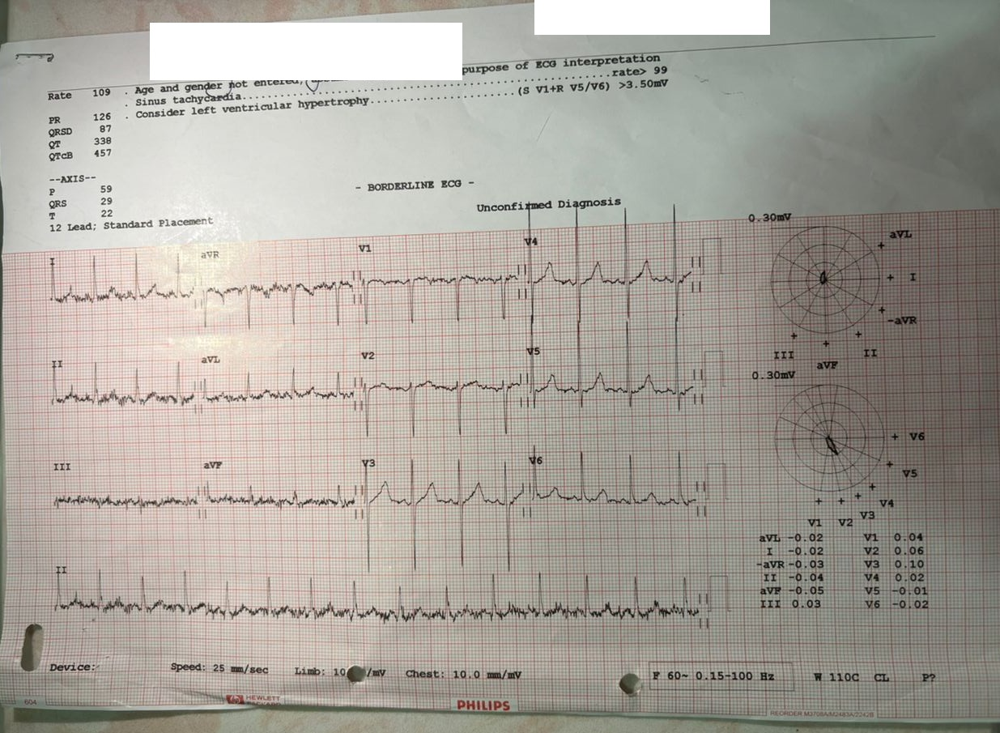
Fig. 2 Twelve-lead electrocardiogram on admission showing sinus tachycardia at 109 beats/min. The QT interval was 338 ms; the corrected QT was 457 ms by Bazett's formula and 412 ms by Fridericia's formula. Patient identifiers have been removed
The combination of hypocalcaemia, hyperphosphataemia and an elevated PTH concentration with normal renal function, normal magnesium and replete vitamin D stores is the biochemical signature of PTH resistance (Cooper and Gittoes 2008; Mantovani et al. 2018). The causes of hypocalcaemia with an elevated PTH were considered systematically, using the biochemical patterns summarised in Table 3 (Cooper and Gittoes 2008).
Table 3 Biochemical patterns that distinguish the causes of hypocalcaemia, with the findings in this patient
Condition | Phosphate | PTH | 25-hydroxy-vitamin D | Creatinine | Magnesium
Hypoparathyroidism (surgical, autoimmune, genetic) | High | Low or inappropriately normal | Normal | Normal | Normal
Pseudohypoparathyroidism (PTH resistance) | High | High | Normal | Normal | Normal
Vitamin D deficiency | Low or normal | High | Low | Normal | Normal
Chronic kidney disease | High | High | Variable | High | Normal or high
Hypomagnesaemia | Normal | Low or inappropriately normal | Normal | Normal | Low
Acute phosphate load (tumour lysis, rhabdomyolysis) | High | High | Normal | Often high | Variable
This patient | High (1.60 mmol/L) | High (176.8 pg/mL) | Normal (37.7 ng/mL) | Normal (53.7 µmol/L) | Normal (1.03 mmol/L)
All conditions listed are associated with a low serum calcium. Patterns compiled from (Cooper and Gittoes 2008). PTH, parathyroid hormone
Hypoparathyroidism (surgical, autoimmune or genetic) produces hypocalcaemia with hyperphosphataemia, but PTH is low or inappropriately normal; here PTH was more than twice the upper reference limit and there was no history of neck surgery or irradiation. Chronic kidney disease with secondary hyperparathyroidism produces the same triad as PHP but was excluded by a normal creatinine and normal renal ultrasonography. Vitamin D deficiency was excluded by a replete 25-hydroxyvitamin D concentration and, more decisively, by the direction of the phosphate change: vitamin D deficiency usually causes hypophosphataemia, although severe deficiency can transiently mimic PHP (Akın et al. 2010; Seki et al. 2010). Hypomagnesaemia, which impairs both PTH secretion and PTH action, was excluded by a normal magnesium. Respiratory alkalosis was excluded by the arterial blood gas. An acute phosphate load from tumour lysis or rhabdomyolysis was not supported by the five-month history, the normal renal function and the absence of any provoking illness.
Tetanus was the most important clinical mimic because of the trismus and generalised spasms. The sensory prodrome of perioral and acral paraesthesia, the symmetrical carpopedal spasms, the positive Chvostek's and Trousseau's signs, the absence of a wound, of risus sardonicus and of autonomic instability, and the rapid resolution of symptoms with intravenous calcium all pointed to hypocalcaemic tetany rather than tetanus (Table 4) (Cooper and Gittoes 2008; Yen and Thwaites 2019).
Table 4 Features that distinguish hypocalcaemic tetany from generalised tetanus
Feature | Hypocalcaemic tetany | Generalised tetanus
Prodrome | Perioral and acral paraesthesia, muscle cramps | Wound or portal of entry; incomplete immunisation; trismus is usually the first sign
Pattern of spasm | Symmetrical carpopedal spasm (main d'accoucheur), laryngospasm; trismus uncommon | Trismus, risus sardonicus, opisthotonus, generalised spasms triggered by touch, noise or light
Chvostek's and Trousseau's signs | Usually positive | Absent
Autonomic disturbance | Absent | Common in severe disease (labile blood pressure, tachycardia, sweating, arrhythmia)
Consciousness | Preserved between spasms; seizures may occur | Preserved
Serum calcium | Low | Normal
Electrocardiogram | QT prolongation may be present | Autonomic tachyarrhythmias in severe disease
Response to intravenous calcium | Rapid resolution | None
Compiled from published reviews of hypocalcaemia (Cooper and Gittoes 2008) and of tetanus (Yen and Thwaites 2019)
On the basis of the clinical and biochemical findings a diagnosis of PHP was made. The phenotype, with isolated PTH resistance, normal thyroid function, no AHO features, no affected relatives and a first presentation in adult life, is most consistent with PHP type 1B, but molecular subtyping was not possible because GNAS methylation and sequencing studies were unavailable.

Therapeutic intervention
Symptomatic hypocalcaemia was treated as an emergency with intravenous calcium gluconate, given as repeated 2 g boluses (20 mL of 10% solution) until clinical improvement was achieved, in line with published emergency guidance (Turner et al. 2016). The perioral twitching, jaw stiffness and carpopedal spasms resolved completely within 24 hours. She was then started on oral calcitriol 0.25 µg once daily and calcium carbonate 500 mg twice daily, and was counselled about dietary calcium, the need for long-term treatment and the importance of regular monitoring.

Follow-up and outcomes
She tolerated the transition to oral therapy and was discharged on the fifth day of admission, clinically well, with endocrine follow-up arranged. Genetic testing was recommended for molecular classification and genetic counselling but was not available locally. A detailed family history was taken and first-degree relatives were assessed clinically and biochemically; none had features suggestive of PHP. Follow-up includes monitoring of serum calcium, phosphate and PTH, thyroid function and renal function, and surveillance for the complications of chronic PTH resistance and of its treatment. At more than three months of follow-up she remained well and free of neuromuscular symptoms.

Discussion

Making the diagnosis of a rare disease on biochemical grounds
The international consensus on PHP and related disorders recommends that the diagnosis be made from clinical and biochemical findings, with molecular testing used to confirm the mechanism and define the subtype where it is available (Mantovani et al. 2018; Mantovani et al. 2020). The reasoning is physiological. PTH acts through the PTH1 receptor and the stimulatory G protein to promote renal phosphate excretion, to increase distal tubular calcium reabsorption and to stimulate 1α-hydroxylation of 25-hydroxyvitamin D. When proximal tubular signalling fails, phosphate is retained, 1,25-dihydroxyvitamin D synthesis falls, calcium falls, and the parathyroid glands respond appropriately with a sustained rise in PTH (Jüppner 2021; Mantovani et al. 2018). Hypocalcaemia with hyperphosphataemia and an elevated PTH in a patient with normal renal function, normal magnesium and adequate vitamin D therefore has few explanations other than PTH resistance, and each alternative in our patient could be excluded with tests that are available in most referral hospitals. For a rare disease in a setting without genetic services, this biochemical pathway is the diagnosis.

Adult presentation without the classical phenotype
Although most patients are diagnosed in childhood, the Danish national cohort recorded a mean age at diagnosis of 13 years with a range extending to 62 years (Underbjerg et al. 2016), a Colombian series described four adults diagnosed late after years of unexplained symptoms (Trejo et al. 2018), and adult first presentations continue to be reported (Ebrahim et al. 2025; Najim et al. 2020; Shah et al. 2021). PHP type 1A, caused by maternally inherited inactivating GNAS mutations, is accompanied by AHO and by resistance to several hormones; PHP type 1B, which is most often sporadic and caused by methylation defects at GNAS, usually presents with isolated PTH resistance, with or without mild thyrotropin resistance, and with few or no AHO features (Jüppner 2021; Mantovani et al. 2018). Obesity occurs in both and does not discriminate between them. Our patient's normal stature and hands, isolated PTH resistance, normal thyroid function, absence of affected relatives and first symptoms in the fifth decade all favour PHP type 1B, but this remains provisional without molecular confirmation. The two published sub-Saharan African cases, from Kenya (Gicheru et al. 1983) and Ghana (Akpalu et al. 2023), both had AHO features, and in the Ghanaian patient the diagnosis followed the incidental finding of basal ganglia calcification on CT. Our patient had neither, which underlines that intracranial calcification and the AHO phenotype are supportive but not necessary findings (Mantovani et al. 2018).

Tetany that mimicked tetanus
Ionised calcium stabilises voltage-gated sodium channels in nerve membranes; as it falls, the threshold for depolarisation drops and peripheral nerves discharge spontaneously, producing in sequence paraesthesia, fasciculation, carpopedal spasm and, in severe cases, laryngospasm, trismus and seizures (Cooper and Gittoes 2008). In a country where tetanus still occurs, trismus with generalised spasms invites the wrong diagnosis, and the two conditions require entirely different treatment. The features that distinguish them (Table 4) are largely clinical and available at the bedside (Yen and Thwaites 2019). Serum calcium should be measured in every adult with trismus or generalised spasms before tetanus is assumed, and a rapid response to intravenous calcium is itself diagnostic.

The electrocardiogram
Hypocalcaemia lengthens the ST segment and therefore the QT interval, and a prolonged QTc is a useful pointer to a metabolic cause of spasms or seizures (Cooper and Gittoes 2008; Najim et al. 2020). In our patient the QTc by Bazett's formula was 457 ms at a heart rate of 109 beats/min. Bazett's correction overestimates the QTc at rapid heart rates, whereas Fridericia's formula performs better (Vandenberk et al. 2016); by Fridericia the QTc was 412 ms, within the normal range. The tracing therefore showed sinus tachycardia with a borderline QTc, and the case is a reminder that a normal or borderline QTc does not exclude clinically significant hypocalcaemia.

Management principles and implications for rare disease care
Symptomatic hypocalcaemia is a medical emergency and should be treated with intravenous calcium gluconate before the cause is established (Turner et al. 2016). Long-term treatment of PTH resistance rests on an active vitamin D analogue, calcitriol or alfacalcidol, with oral calcium, titrated to keep serum calcium in the normal range and phosphate normal. Because bone remains responsive to PTH in PHP, the consensus also recommends keeping PTH within or only slightly above the reference range, since persistently high concentrations can cause hyperparathyroid bone disease; in this respect PHP differs from hypoparathyroidism, in which PTH cannot serve as a treatment target (Khan et al. 2022; Mantovani et al. 2018). Distal tubular calcium reabsorption is often partly preserved in PHP, so hypercalciuria is a smaller constraint than in hypoparathyroidism, but urinary calcium and renal imaging should still be reviewed periodically. Thyroid function should be checked regularly for thyrotropin resistance, and first-degree relatives should be assessed because some forms are inherited (Mantovani et al. 2018; Mantovani et al. 2020). Genetic counselling and molecular testing should be pursued whenever they become accessible, including through international reference laboratories and disease networks, and cases such as this one argue for national rare disease registries in sub-Saharan Africa, which would allow the true burden of PHP and similar disorders in the region to be measured.

Strengths and limitations
The strengths of this report are the complete biochemical characterisation of PTH resistance, the systematic exclusion of alternative causes, the documented response to treatment and the clinical and biochemical assessment of first-degree relatives. Its limitations are those of the setting. Molecular analysis of GNAS and functional testing of the renal response to PTH were not available, so the subtype is provisional. Hand radiographs, a slit-lamp examination for cataract and urinary calcium and phosphate measurements were not obtained. The ionised calcium concentration was disproportionately low relative to the total and albumin-corrected calcium and was a single measurement, so pre-analytical factors cannot be excluded. Follow-up beyond three months is continuing.

Conclusion
PHP can present for the first time in adult life without the features of AHO and without intracranial calcification. Hypocalcaemia with hyperphosphataemia and an elevated PTH in a patient with normal renal function, normal magnesium and adequate vitamin D is the biochemical signature of PTH resistance and justifies a clinical diagnosis and immediate treatment where molecular testing is unavailable. Trismus and generalised spasms in a hypocalcaemic adult can mimic tetanus; a preceding sensory prodrome, symmetrical carpopedal spasms, positive Chvostek's and Trousseau's signs and a rapid response to intravenous calcium distinguish tetany, and serum calcium should be measured in every patient in whom tetanus is suspected. Long-term management uses calcitriol and oral calcium titrated to normal calcium and phosphate, with PTH kept within or slightly above the reference range, together with screening for thyroid hormone resistance and assessment of first-degree relatives.

Statements and Declarations

Acknowledgements
The authors thank the patient and her family for their cooperation and consent.

Funding
The authors did not receive support from any organisation for the submitted work.

Author contributions
All authors contributed to the conception of the report. Clinical care, data collection and the first draft of the case presentation were the work of David George, Denis Rayner and Silas Frank Gamba. James Masanja performed the literature review and wrote the first draft of the discussion. All authors commented on previous versions of the manuscript, read and approved the final manuscript, and agree to be accountable for its content.

Ethics approval
This report describes the routine clinical care of a single patient. Institutional permission for publication was obtained in accordance with the policy of Muhimbili National Hospital, and the work was carried out in accordance with the Declaration of Helsinki.

Consent to participate
Written informed consent was obtained from the patient.

Consent to publish
The patient signed informed consent for publication of her clinical details and the images in Figs. 1 and 2, from which all identifying information has been removed.

Competing interests
The authors have no competing interests to declare that are relevant to the content of this article.

Data availability
All data generated or analysed during this study are included in this published article.

Use of generative AI and AI-assisted technologies
An artificial intelligence language tool was used to assist with language editing, formatting and reference checking. All clinical content and interpretation were provided, reviewed and validated by the authors, and no clinical image was generated or altered with generative AI.

References
Akın L, Kurtoğlu S, Yıldız A, Akın MA, Kendirici M. Vitamin D deficiency rickets mimicking pseudohypoparathyroidism. J Clin Res Pediatr Endocrinol. 2010;2:173–5. https://doi.org/10.4274/jcrpe.v2i4.173
Akpalu J, Ampong C, Adiiboka JG, Nikoi E, Atiase Y, Yorke E. Parathyroid hormone resistance: an uncommon cause of hypocalcaemia in an adult Ghanaian female. West Afr J Med. 2023;40:1131–4.
Cooper MS, Gittoes NJL. Diagnosis and management of hypocalcaemia. BMJ. 2008;336:1298–302. https://doi.org/10.1136/bmj.39582.589433.BE
Ebrahim R, Peedika Parambil N, Poolakundan H, Sonibare AD, Poolakundan FJ. Late-onset pseudohypoparathyroidism: a case report. Cureus. 2025;17:e93475. https://doi.org/10.7759/cureus.93475
Gicheru K, Shah MV, Gitau W, Gathua SN. Pseudohypoparathyroidism: a case report. East Afr Med J. 1983;60:814–21.
Jüppner H. Molecular definition of pseudohypoparathyroidism variants. J Clin Endocrinol Metab. 2021;106:1541–52. https://doi.org/10.1210/clinem/dgab060
Khan AA, Bilezikian JP, Brandi ML, Clarke BL, Gittoes NJ, Pasieka JL, et al. Evaluation and management of hypoparathyroidism summary statement and guidelines from the Second International Workshop. J Bone Miner Res. 2022;37:2568–85. https://doi.org/10.1002/jbmr.4691
Mantovani G, Bastepe M, Monk D, de Sanctis L, Thiele S, Usardi A, et al. Diagnosis and management of pseudohypoparathyroidism and related disorders: first international Consensus Statement. Nat Rev Endocrinol. 2018;14:476–500. https://doi.org/10.1038/s41574-018-0042-0
Mantovani G, Bastepe M, Monk D, de Sanctis L, Thiele S, Ahmed SF, et al. Recommendations for diagnosis and treatment of pseudohypoparathyroidism and related disorders: an updated practical tool for physicians and patients. Horm Res Paediatr. 2020;93:182–96. https://doi.org/10.1159/000508985
Najim MS, Ali R, Awad M, Omer A. Pseudohypoparathyroidism presenting with seizures: a case report and literature review. Intractable Rare Dis Res. 2020;9:166–70. https://doi.org/10.5582/irdr.2020.03014
Riley DS, Barber MS, Kienle GS, Aronson JK, von Schoen-Angerer T, Tugwell P, et al. CARE guidelines for case reports: explanation and elaboration document. J Clin Epidemiol. 2017;89:218–35. https://doi.org/10.1016/j.jclinepi.2017.04.026
Seki T, Yamamoto M, Kimura H, Tsuiki M, Ono M, Miki N, et al. Vitamin D deficiency in two young adults with biochemical findings resembling pseudohypoparathyroidism type I and type II. Endocr J. 2010;57:735–44. https://doi.org/10.1507/endocrj.K10E-097
Shah FA, Fujikawa P, Braford M, Patel K, Rasul K. Is all hypocalcemia due to low parathyroid hormone? An unusual case of pseudohypoparathyroidism in a young and healthy patient. Cureus. 2021;13:e16243. https://doi.org/10.7759/cureus.16243
Takatani R, Kubota T, Minagawa M, et al. Prevalence of pseudohypoparathyroidism and nonsurgical hypoparathyroidism in Japan in 2017: a nationwide survey. J Epidemiol. 2023;33:569–73.
Thiele S, Mantovani G, Barlier A, Boldrin V, De Sanctis L, Elli FM, et al. From pseudohypoparathyroidism to inactivating PTH/PTHrP signalling disorder (iPPSD), a novel classification proposed by the EuroPHP network. Eur J Endocrinol. 2016;175:P1–17. https://doi.org/10.1530/EJE-16-0107
Trejo MC, Román-González A, Ruíz S, Tobón C, Castaño P, Arango C, et al. Late diagnosis of pseudohypoparathyroidism in adulthood. Case series. Rev Fac Med. 2018;66:643–9. https://doi.org/10.15446/revfacmed.v66n4.66940
Turner J, Gittoes N, Selby P. Society for Endocrinology Endocrine Emergency Guidance: emergency management of acute hypocalcaemia in adult patients. Endocr Connect. 2016;5:G7–8. https://doi.org/10.1530/EC-16-0056
Underbjerg L, Sikjaer T, Mosekilde L, Rejnmark L. Pseudohypoparathyroidism: epidemiology, mortality and risk of complications. Clin Endocrinol (Oxf). 2016;84:904–11. https://doi.org/10.1111/cen.12948
Vandenberk B, Vandael E, Robyns T, Vandenberghe J, Garweg C, Foulon V, et al. Which QT correction formulae to use for QT monitoring? J Am Heart Assoc. 2016;5:e003264. https://doi.org/10.1161/JAHA.116.003264
Yen LM, Thwaites CL. Tetanus. Lancet. 2019;393:1657–68. https://doi.org/10.1016/S0140-6736(18)33131-3

